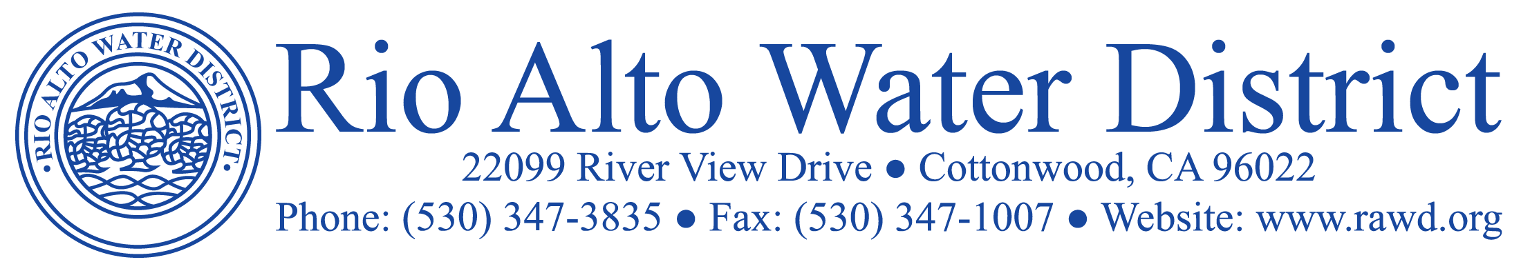

Agenda for the Six Hundred and Fifty First Special Meeting of the Board of Directors of the Rio Alto Water District to be held on Wednesday, January 10, 2024, at 6:30 p.m., at the Lake Club located at 22431 Rio Alto Drive, Cottonwood, CA 96022.

INFORMATIONAL SPECIAL MEETING ONLY - NO ACTION TO BE TAKEN:

- Presentation of the Water and Wastewater Rate Study 2023
and Proposed Rate Increases by Bartle Wells Associates.

- Public Question and Answer Period.

Note: The Board of Directors, may, at any time throughout the meeting, open or close
discussion or change the order of any Agenda item listed as necessary to facilitate the orderly transaction of District Business.

Note: Parties with a disability as provided by the American Disabilities Act who require special accommodations or aids in order to participate in a public hearing should make the request to the District Staff at least 48 hours prior to the meeting.

